**SPRINT-3**

|  |  |
| --- | --- |
| Date | 13 November 2022 |
| Project Name | Smart Farmer - IoT Enabled Smart Farming  Application |
| TEAM ID | PNT2022TMID15139 |

PROCEDURE:

* Open IBM Cloud and search Node-RED in catalog.
* Create Node-RED configuration and visit the app URL.
* Construct all nodes for Smart farm and enter all configuration in nodes.
* After configuring click deploy and see the output in python IDLE and debug
* Visit the api web and monitor the temperature and humidity reading.

Creation of Node-RED

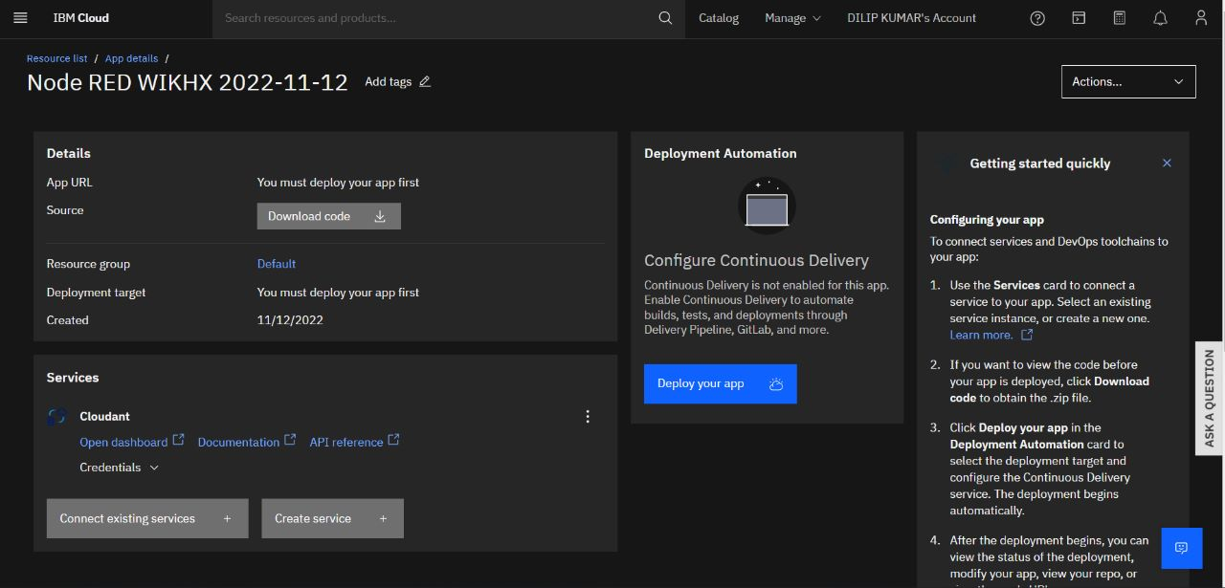

Run the Node-RED and launch the URL from IBM Cloud

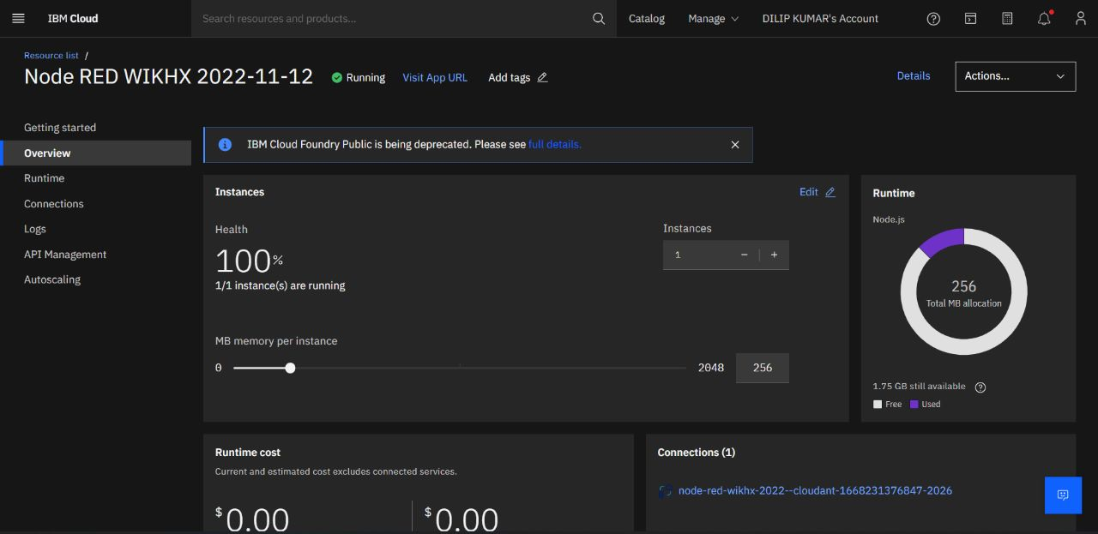

Construction of Nodes

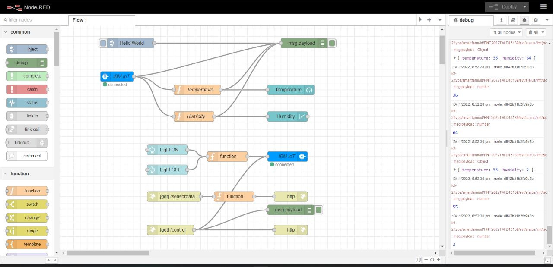

Monitoring the sensor nodes

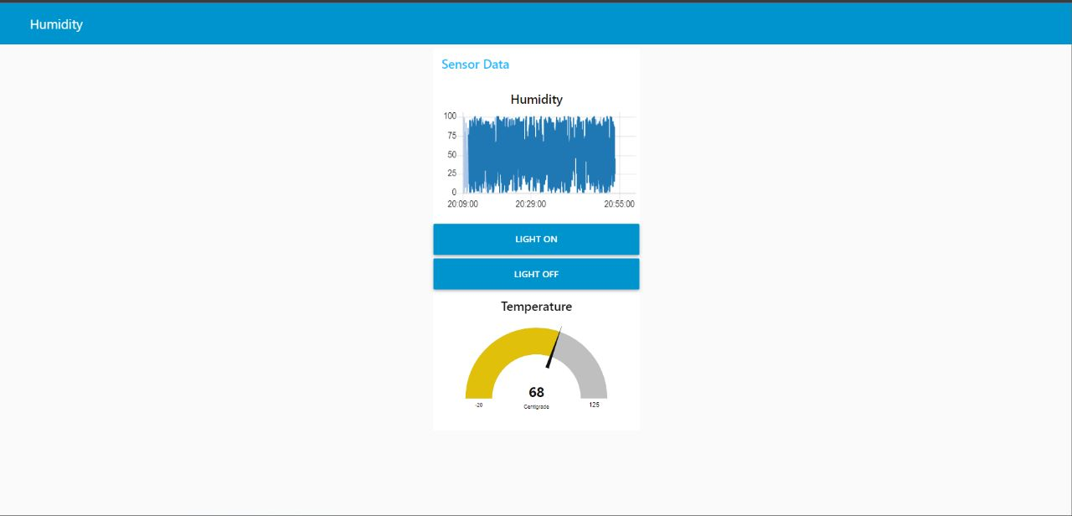

Configuring the IBM Nodes

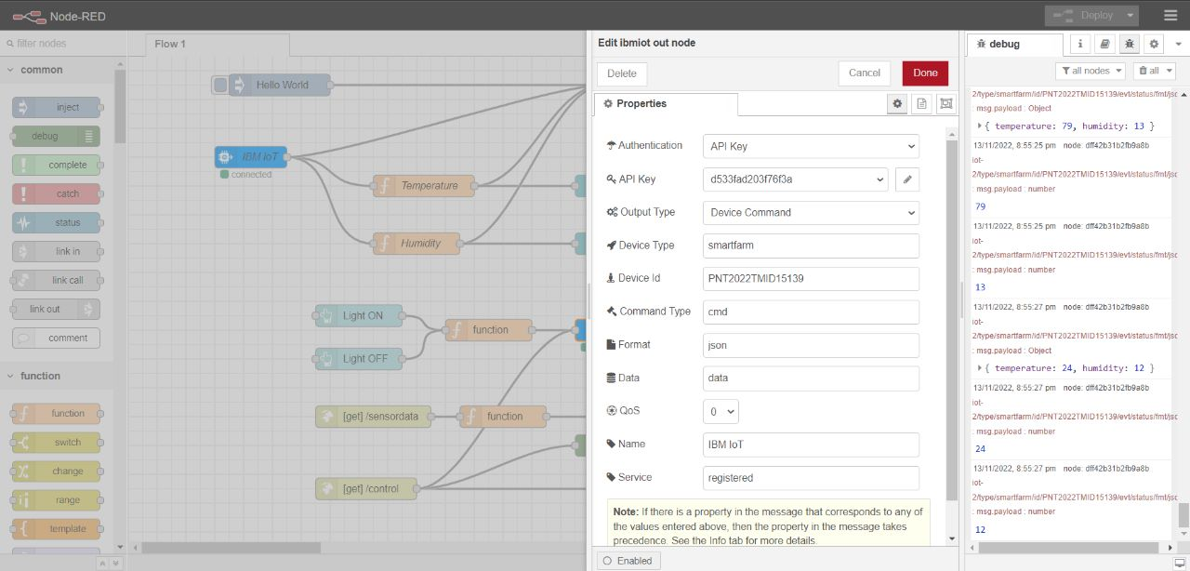

Interfacing Node-RED and MIT App Inventor

